E-Commerce new Website

Logo:

Color Concept: #202734, #36415A, #B7D894, #E0F8C7


Name: Muralla Tech

Concept: Tech & Electronics E-Commerce Website

Title & Headings: Syne or Plus Jakarta Sans

Subtitles & Badges: Plus Jakarta Sans (Semi-Bold / Bold, All Caps with letter spacing)

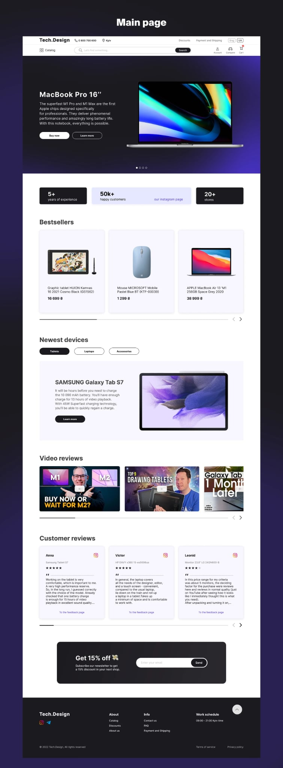
Body Text & Product Cards: Inter
Design Concept:

E-Commerce Website Activity Develop a simple E-commerce platform with transaction capability. Your website should: Contain at least 30 unique products organized into logical categories (e.g., fashion, gadgets, beauty, etc.). Include shopping cart, checkout, and payment simulation features to demonstrate end-to-end transactions. Have a modern and creative interface — your design must be more appealing and interactive than leading platforms such as Shopee and Lazada. Ensure security, functionality, and responsive. General Requirements Apply good UI/UX design principles (readability, contrast, layout balance, and accessibility). Use modern web technologies such as HTML5, CSS3, JavaScript The final output must reflect creativity, technical proficiency, and real-world application.

